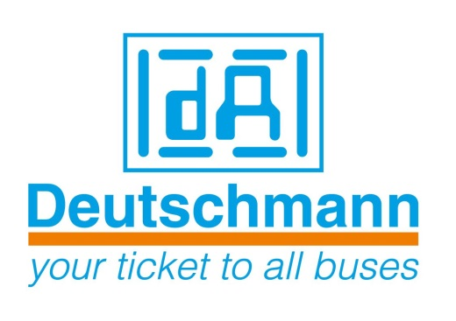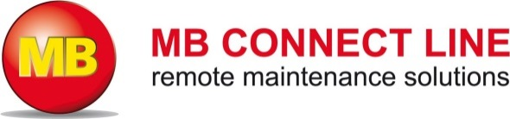

Deutschmann Automation
GmbH & Co.KG
Carl-Zeiss-Straße 8
65520 Bad Camberg
Phone: +49 6434 94330Email: info@deutschmann.de
Internet: www.deutschmann.de

PRESS RELEASE 04/2015_E

For publication approved: November 24, 2015

At the SPS IPC Drives 2015: Deutschmann Automation and MB connect line have announced a strategic partnership

Bad Camberg, Germany – Deutschmann Automation, the specialist for industrial data communication, and MB connect line, the expert for solutions in remote maintenance of systems, have announced a strategic partnership at the SPS IPC Drives 2015 exhibition in Nuremberg, Germany. The goal of the agreement is development and manufacture of innovative key products and solutions for Industry 4.0 applications.

These two medium-sized German companies, whose core competencies ideally complement one another, want to join forces to move forward together to meet both the different requirements of the individual future markets and the varied demands that customers have. The focus will be on secure data communication in the networked industry of the future, for example, in order to connect the fieldbus world with the internet world. 'Made in Germany', a sign that still plays an important role both nationally and internationally, is a key point for both companies.

Michael M. Reiter, General Manager Marketing and Sales, Deutschmann Automation, says: “Small and medium-sized enterprises often do not have the ability to implement and market innovative ideas by themselves. We are therefore pleased to have found a reliable partner in MB connect line, a company that ideally complements our know-how. Over the next few years, we will jointly bring new secure industrial data communication solutions onto the market. The first products are expected to be ready in 2016.”

Siegfried Müller, General Manager, MB connect line, says: “To remain successful in the marketplace in the future, we as small and medium-sized enterprises must combine our knowledge and expertise. Thanks to the partnership with Deutschmann Automation, we will expand our remote maintenance solution downwards towards the field level, in order to provide even better support for our customers in the implementation of Industry 4.0. Our advantage is that we can act much faster and more flexibly compared with large enterprises. Furthermore, we therefore ultimately also safeguard our jobs in Germany.”

Deutschmann Automation, located in Bad Camberg, Germany, has developed and manufactured numerous protocol converters, fieldbus and Industrial Ethernet gateways, and embedded solutions as well as suitable development tools under the brand name UNIGATE since two decades.

MB connect line is an expert for solutions in remote maintenance of machines, plants and infrastructure via the internet. A core product is the centralized remote service platform mbCONNECT24 as a universal solution for remote maintenance, data collection and M2M communication.

Deutschmann Automation

Deutschmann Automation is a German company located in Bad Camberg. For more than three decades, the company has designed and manufactured innovative network components for the sector of industrial data communication. Various series of Fieldbus and Industrial Ethernet gateways, and embedded solutions as well as development tools for the realization of Industry 4.0 are offered under the brand name UNIGATE. Thanks to competent quality management and the continuous further development of all products, Deutschmann Automation is one of the leading providers in the sector of automation.

MB connect line

The MB connect line GmbH offers universal solutions for worldwide remote maintenance data acquisition and M2M communication of machines and equipment. All necessary services and functions are integrated centrally on the web-based remote service platform mbCONNECT24. It is suitable for building technology and mobile machinery as well as for production plants and utility infrastructure.

Deutschmann Automation
GmbH & Co.KG
Michael Reiter
Carl-Zeiss-Straße 8
65520 Bad Camberg
Phone: +49 6434 94330
Email: info@deutschmann.de
Internet: www.deutschmann.de

MB connect line GmbH
Siegfried Müller
Winnettener Straße 6
91550 Dinkelsbühl
Phone: +49 9851 582529 0
Email: info@mbconnectline.de
Internet: www.mbconnectline.de

Technisches Redaktionsbüro

Rosemarie Krause

Leibengerstr. 29

81829 München

Phone: +49 89 906637

