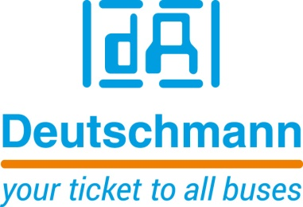

Deutschmann Automation
GmbH & Co.KG
Carl-Zeiss-Straße 8
65520 Bad Camberg
Phone: +49 6434 94330Email: info@deutschmann.de
Internet: www.deutschmann.de

PRESS RELEASE 02/2018_E

For publication approved: April 2018

Deutschmann Automation: All-in-One Bus Node for POWERLINK Connectivity

Bad Camberg, Germany – Deutschmann Automation, the specialist for industrial data communication, presents the flexible UNIGATE IC POWERLINK module. The powerful all-in-one bus node implements a POWERLINK connectivity according to the open Ethernet Powerlink Standardization Group (EPSG) standard. The globally established POWERLINK bus protocol not only features fast transmission speed but also high real-time capability.
With the ready-to-use UNIGATE IC POWERLINK, development costs and time-to-market of the final product can be significantly optimized compared with an interface developed by customers themselves. As with every all-in-one bus node of the UNIGATE family, the new module can be easily integrated. The actual application of the customer is altered as little as possible.
UNIGATE IC POWERLINK consists of a microcontroller, Flash, RAM, and two Ethernet POWERLINK interfaces including PHYs. The module can be connected via a UART interface to the microcontroller of the terminal device. It is also suitable for stand-alone operation.

An easy-to-learn, self-explaining script language allows for the connection of the all-in-one bus node and the terminal device. Deutschmann’s Protocol Developer is a free tool for generation of the script. It is easy to use and specifically optimized to the bus communication. The programming allows the mapping of complex applications, which cannot be presented via a pure configuration.

Deutschmann Automation delivers various series of Fieldbus and Industrial Ethernet gateways, and embedded solutions as well as development tools for the realization of Industry 4.0 under the brand name UNIGATE. The compatible data communication products are developed and manufactured in Germany.

Deutschmann Automation

Deutschmann Automation is a German company located in Bad Camberg. For more than two decades, the company has designed and manufactured innovative network components for the sector of industrial data communication. Various series of Fieldbus and Industrial Ethernet gateways, and embedded solutions as well as development tools for the realization of Industry 4.0 are offered under the brand name UNIGATE. Thanks to competent quality management and the continuous further development of all products, Deutschmann Automation is one of the leading providers in the sector of automation.

Deutschmann Automation
GmbH & Co.KG
Michael Reiter
Carl-Zeiss-Straße 8
65520 Bad Camberg
Phone: +49 6434 94330
Email: info@deutschmann.de
Internet: www.deutschmann.de

Technisches Redaktionsbüro

Rosemarie Krause

Leibengerstr. 29

81829 München

Phone: +49 89 906637

