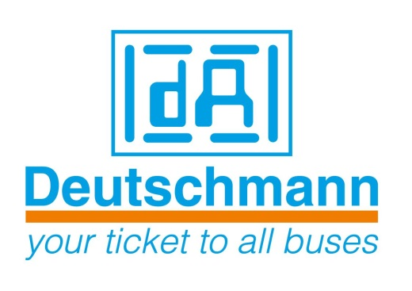

Deutschmann Automation
GmbH & Co.KG
Carl-Zeiss-Straße 8
65520 Bad Camberg
Phone: +49 6434 94330
Email: info@deutschmann.de
Internet: www.deutschmann.de

PRESS RELEASE 02/2015_E

For publication approved: October 22, 2015

Deutschmann Automation at SPS/IPC/Drives:
Easily configurable, ready-to-use CAN gateways

Bad Camberg, Germany – Deutschmann Automation, the specialist for industrial data communication, presents its UNIGATE CM CANopen gateway series in Hall 2, Booth 240 at the SPS IPC Drives exhibition in Nuremberg, Germany from November 24 to 26, 2015 and at the booths of Profibus & PROFINET, EtherCAT and ODVA organizations. The gateway is used as an Industry 4.0 core component in devices, which operate internally with CAN or CANopen and are to be connected to other popular Fieldbus and Industrial Ethernet systems. With the Deutschmann developed software WINGATE, the reliable components can be quickly and easily configured and immediately be put into operation. The compact IP20 module with dimensions of 23 mm x 115 mm x 100 mm can be easily mounted on the DIN rail.

Besides RS232, RS485 and RS422 standard interfaces, the UNIGATE CM CANopen Gateway has an additional CAN/CANopen master interface with Mini-Master functionality. Hence, the gateways can connect both CANopen networks and individual CANopen devices into higher-level networks. Adaptation of the device-firmware is not necessary. After configuration of the parameters, the gateway is immediately ready for communication. The adjustable values are context-sensitive displayed, dependent on the selected function parameters. Furthermore, the module can be very flexibly programmed with the Deutschmann developed script language.

On request ‒ as for all gateways and protocol converters from Deutschmann ‒ the Option I/O 8 is available, with which eight digital I/Os (24 V) can be configured both via the configuration software and by script.

UNIGATE CM is designed for the industrial operating temperature range. Deutschmann optionally supplies the product pre-configured to customer specification, in different housing colors and with or without the customer logo.

Deutschmann Automation can be found in Hall 2, Booth 240 at the SPS IPC Drives exhibition in Nuremberg, Germany from November 24 to 26, 2015 and at the booths of Profibus & PROFINET, EtherCAT and ODVA organizations.

Deutschmann Automation

Deutschmann Automation is a German company located in Bad Camberg. For more than three decades, the company has designed and manufactured innovative network components for the sector of industrial data communication. Various series of Fieldbus and Industrial Ethernet gateways, and embedded solutions as well as development tools for the realization of Industry 4.0 are offered under the brand name UNIGATE. Thanks to competent quality management and the continuous further development of all products, Deutschmann Automation is one of the leading providers in the sector of automation.

Deutschmann Automation
GmbH & Co.KG
Michael Reiter
Carl-Zeiss-Straße 8
65520 Bad Camberg
Phone: +49 6434 94330
Email: info@deutschmann.de
Internet: www.deutschmann.de

Technisches Redaktionsbüro

Rosemarie Krause

Leibengerstr. 29

81829 München

Phone: +49 89 906637

