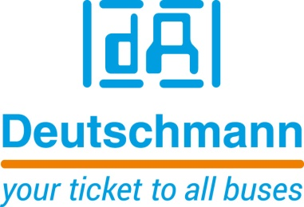

Deutschmann Automation
GmbH & Co.KG
Carl-Zeiss-Straße 8
65520 Bad Camberg
Phone: +49 6434 94330Email: info@deutschmann.de
Internet: www.deutschmann.de

PRESS RELEASE 01/2018_E

For publication approved: February 2018

Deutschmann Automation at embedded world 2018:
Powerful PROFIBUS Connectivity

Bad Camberg, Germany – Deutschmann Automation, the specialist for industrial data communication, presents a further developed version of its UNIGATE IC PROFIBUS module at the embedded world 2018 in Hall 2, Booth 629. The powerful all-in-one bus node enables simple and fast installation in a terminal device or sensor system and provides reliable PROFIBUS connectivity. With UNIGATE IC products, development costs and the time-to-market of network-capable systems can be significantly optimized.
With the further development of the UNIGATE IC PROFIBUS, Deutschmann is responding to the still strong demand for fieldbus modules, which is continuing despite industrial Ethernet solutions moving into the market. However, the demands on performance of the modules have increased recently and, therefore; adapting the products to modern tasks makes sense. Deutschmann also plans to develop more powerful versions of other fieldbus modules from its product portfolio. PROFIBUS is the first step.
The new UNIGATE IC PROFIBUS module is based on an actual 32-bit ARM Cortex-M4 microcontroller. The powerful module is, of course, pin- and function-compatible with existing PROFIBUS products from Deutschmann and can, therefore, be used flexibly and be interchanged with very little effort. If required, the possibility thus exists to easily upgrade terminal devices.
The existing scripts for protocol connection of the all-in-one bus node to the terminal device can continue to be used. The scripts can be programmed via the Deutschmann Automation developed script language. The consistent compatibility of all modules ensures the long-term availability of UNIGATE IC PROFIBUS solutions.
The powerful UNIGATE IC PROFIBUS module is available in two versions for supply voltages of 3.3V and 5V respectively. The new product will be available in the second quarter of 2018.

Please visit Deutschmann Automation at embedded world 2018 in Hall 2, Booth 629.

Deutschmann Automation

Deutschmann Automation is a German company located in Bad Camberg. For more than two decades, the company has designed and manufactured innovative network components for the sector of industrial data communication. Various series of Fieldbus and Industrial Ethernet gateways, and embedded solutions as well as development tools for the realization of Industry 4.0 are offered under the brand name UNIGATE. Thanks to competent quality management and the continuous further development of all products, Deutschmann Automation is one of the leading providers in the sector of automation.

Deutschmann Automation
GmbH & Co.KG
Michael Reiter
Carl-Zeiss-Straße 8
65520 Bad Camberg
Phone: +49 6434 94330
Email: info@deutschmann.de
Internet: www.deutschmann.de

Technisches Redaktionsbüro

Rosemarie Krause

Leibengerstr. 29

81829 München

Phone: +49 89 906637

