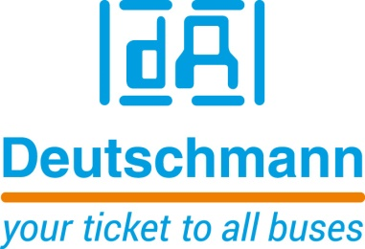

Deutschmann Automation
GmbH & Co.KG
Carl-Zeiss-Straße 8
65520 Bad Camberg
Phone: +49 6434 94330Email: info@deutschmann.de
Internet: www.deutschmann.de

PRESS RELEASE 01/2017_E

For publication approved: February 2017

Deutschmann Automation at embedded world 2017:
Fast and secure way to Industrial Ethernet

Bad Camberg, Germany – Deutschmann Automation, the specialist for industrial data communication, presents the UNIGATE IC series embedded solution in Hall 3A, Booth 325 at embedded world 2017. UNIGATE IC supports the fast and secure implementation of common fieldbus and Industrial Ethernet interfaces. The flexible all-in-one bus node implements a network connection directly in a device or in a sensor system, thus making it Industry 4.0 capable.

Since UNIGATE IC is easily integrable and immediately executable, the development time and the time to market of the end product can be optimized considerably compared to interfaces that are realized by the customers themselves. The advantage is that, by installing a standardized module, the development costs can be reduced even in the case of larger quantities, which brings about high competitiveness of the product.

Speaking for buying instead of making is also the modularity of the offered communication interfaces. Generally, the customer application is to be capable of accomplishing as many tasks as possible and flexibly connectible to different bus protocols. The individual gateways offered by Deutschmann Automation are pin-compatible with each other and easily exchangeable depending on the application.

Deutschmann Automation has developed an easy-to-learn, self-explaining script language for the proprietary connection of the UNIGATE module and the terminal device. The programming allows the mapping of complex applications, which cannot be presented via a pure configuration. Deutschmann’s Protocol Developer is a free tool for generation of the script. It is easy to use and specifically optimized to the bus communication. The scripts run on all UNIGATE IC variants.

The UNIGATE IC all-in-one bus node is available for all common fieldbus and Industrial Ethernet standards PROFIBUS, PROFINET, EtherNet, EtherNet/IP, EtherCAT, DeviceNET, as well as for Modbus RTU, Modbus TCP, CANopen and LonWorks. With the implementation, the custom-owned application is not effected.

The powerful embedded solution is equipped by Deutschmann Automation in Germany. The communication specialist offers to execute certain certifications and compliance tests for the numerous fieldbuses on customer’s request

Please visit Deutschmann Automation at embedded world in Hall 3A, Booth 325.

Deutschmann Automation

Deutschmann Automation is a German company located in Bad Camberg. For more than two decades, the company has designed and manufactured innovative network components for the sector of industrial data communication. Various series of Fieldbus and Industrial Ethernet gateways, and embedded solutions as well as development tools for the realization of Industry 4.0 are offered under the brand name UNIGATE. Thanks to competent quality management and the continuous further development of all products, Deutschmann Automation is one of the leading providers in the sector of automation.

Deutschmann Automation
GmbH & Co.KG
Michael Reiter
Carl-Zeiss-Straße 8
65520 Bad Camberg
Phone: +49 6434 94330
Email: info@deutschmann.de
Internet: www.deutschmann.de

Technisches Redaktionsbüro

Rosemarie Krause

Leibengerstr. 29

81829 München

Phone: +49 89 906637

