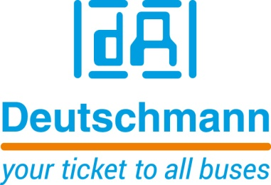

Deutschmann Automation
GmbH & Co.KG
Carl-Zeiss-Straße 8
65520 Bad Camberg
Phone: +49 6434 94330Email: info@deutschmann.de
Internet: www.deutschmann.de

PRESS RELEASE 03/2019_E

For publication approved: November 2019

sps 2019: Deutschmann Automation Presents Flexible Gateway
Series for Different Fieldbus and Industrial Ethernet Networks

Bad Camberg, Germany – Deutschmann Automation, the specialist for industrial data communication, presents the flexible UNIGATE CX series DIN rail modules - for industrial communication applications - at sps 2019 in Hall 5, Booth 328. The gateway series provides almost any combination of different, common fieldbus and Industrial Ethernet interfaces to connect incompatible networks. By using a UNIGATE CX gateway, system manufacturers can save themselves the time-consuming development of suitable network interfaces and significantly reduce the development time for their products.

The flexible UNIGATE CX gateway series is based on two UNIGATE CL modules from Deutschmann Automation. Thanks to the modular design, more than 120 variants of fieldbus and Industrial Ethernet interface solutions can be implemented, e.g. PROFIBUS DP to PROFINET, CANopen to EtherNet/IP or Modbus TCP to PROFINET.

To ensure high flexibility, the UNIGATE CX gateways can be configured quickly and conveniently using the WINGATE software developed by Deutschmann. More complex applications that cannot be presented via configuration can be programmed using the in-house developed script language. The free Protocol Developer tool from Deutschmann, which is optimized for bus communication tasks, is available for generating the script. Programming can be carried out by the customer or by Deutschmann. An adaptation of the hardware or software of the terminal device is not necessary.

Under the brand name UNIGATE, Deutschmann Automation supplies quickly installable, reliable network components as central building blocks for Industry 4.0 applications that come very close to a plug and play solution. The compatible data communication products are developed and manufactured in Germany.

Please visit Deutschmann Automation at sps 2019 in Nuremberg in Hall 5, Booth 328.

Deutschmann Automation

Deutschmann Automation is a German company located in Bad Camberg. For more than two decades, the company has designed and manufactured innovative network components for the sector of industrial data communication. Various series of Fieldbus and Industrial Ethernet gateways, and embedded solutions as well as development tools for the realization of Industry 4.0 are offered under the brand name UNIGATE. Thanks to competent quality management and the continuous further development of all products, Deutschmann Automation is one of the leading providers in the sector of automation.

Deutschmann Automation
GmbH & Co.KG
Michael Reiter
Carl-Zeiss-Straße 8
65520 Bad Camberg
Phone: +49 6434 94330
Email: info@deutschmann.de
Internet: www.deutschmann.de

Technisches Redaktionsbüro

Rosemarie Krause

Leibengerstr. 29

81829 München

Phone: +49 89 906637

