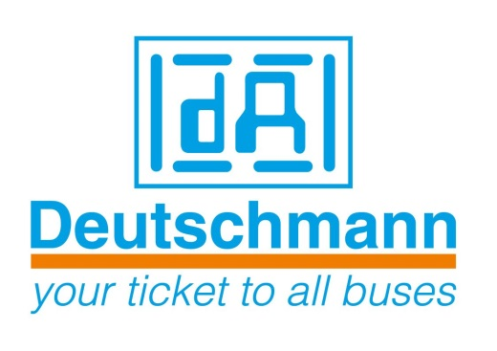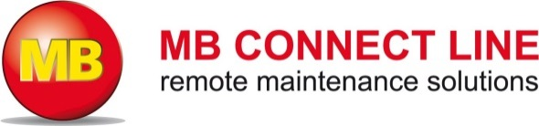

Deutschmann Automation
GmbH & Co.KG
Carl-Zeiss-Straße 8
65520 Bad Camberg
Phone: +49 6434 94330Email: info@deutschmann.de
Internet: www.deutschmann.de

PRESS RELEASE 03/2016_E

For publication approved: April 05, 2016

Deutschmann Automation and MB Connect Line present solution for secure data communication into the cloud

Böblingen, Germany – Within the framework of their strategic partnership, announced at SPS IPC Drives 2015, Deutschmann Automation and MB connect line present their first joint project “Secure Cloud Gateways”. The Secure Cloud Gateways enable a secure and reliable data communication from the fieldbus level into the internet world and are thus key products for Industry 4.0 applications.

The goal of the “Secure Cloud Gateways” joint project is the development of an effective (100%) protection against unauthorized external access to sensitive areas and field level data. The key aspect of the new solution is a hardware-based data diode that allows communication in one direction only – namely from the data source to the cloud interface, but not vice versa. Communication from the cloud interface to the data source is blocked in terms of hardware. Both unauthorized data tapping and insertion of damaging software in the form of manipulated program code is thus reliably prevented. In contrast to a traditional firewall, security gaps or a faulty configuration by the user are prevented dependent on the system. Furthermore, the high level of security of the cloud gateways is achieved via a hardened operating system with Secure Boot.

The first products from the Secure Cloud Gateway family support PROFIBUS, PROFINET, Modbus and Ethernet bus protocols. It is possible to store different data in the cloud, for example, consumption data and measurement values, quantity and efficiency reports, alarm signals when the threshold value has been exceeded or signals for predictive maintenance.

The specialist for industrial data communication Deutschmann Automation and the expert for remote management and services MB Connect Line jointly develop solutions for future demands of their target markets in the Industry 4.0 environment. By pooling their complementary core competencies, both medium-sized companies can turn their creative ideas into innovative products even more flexibly and faster. “Made in Germany” is an attribute that still plays an important role both nationally and internationally.

Deutschmann Automation

Deutschmann Automation is a German company located in Bad Camberg. For more than three decades, the company has designed and manufactured innovative network components for the sector of industrial data communication. Various series of Fieldbus and Industrial Ethernet gateways, and embedded solutions as well as development tools for the realization of Industry 4.0 are offered under the brand name UNIGATE. Thanks to competent quality management and the continuous further development of all products, Deutschmann Automation is one of the leading providers in the sector of automation.

MB Connect Line

The MB Connect Line GmbH offers universal solutions for worldwide remote maintenance data acquisition and M2M communication of machines and equipment. All necessary services and functions are integrated centrally on the web-based remote service platform mbCONNECT24. It is suitable for building technology and mobile machinery as well as for production plants and utility infrastructure.

Deutschmann Automation
GmbH & Co.KG
Michael Reiter
Carl-Zeiss-Straße 8
65520 Bad Camberg
Phone: +49 6434 94330
Email: info@deutschmann.de
Internet: www.deutschmann.de

MB Connect Line GmbH
Siegfried Müller
Winnettener Straße 6
91550 Dinkelsbühl
Phone: +49 9851 582529 0
Email: info@mbconnectline.de
Internet: www.mbconnectline.de

Technisches Redaktionsbüro

Rosemarie Krause

Leibengerstr. 29

81829 München

Phone: +49 89 906637

