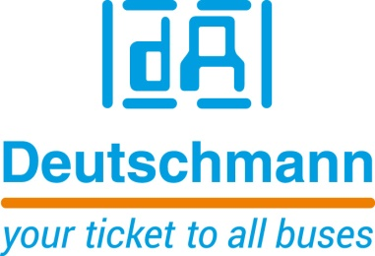

Deutschmann Automation
GmbH & Co.KG
Carl-Zeiss-Straße 8
65520 Bad Camberg
Phone: +49 6434 94330Email: info@deutschmann.de
Internet: www.deutschmann.de

PRESS RELEASE 02/2022_E

For publication approved: October 2022

SPS 2022:
Deutschmann Automation presents new UNIGATE Falcon Protocol Converter/Gateway generation
Bad Camberg, Germany – Deutschmann Automation, the specialist for industrial data communication, presents UNIGATE Falcon, the new generation of its Protocol Converter/Gateway series, at SPS 2022 in Hall 5, Booth 328. The compact DIN-rail modules connect automation components quickly and easily with the desired fieldbus or Industrial Ethernet standard. Implementation of the ready-to-use communication modules can significantly optimize design times and time-to-market of an end product. The UNIGATE Falcon product range is modular in design with the aim of realizing the best possible solution for the respective application in a cost-optimized way.
The new Protocol Converter/Gateway series UNIGATE Falcon features an extremely compact design. With dimensions of 25.0 mm x 77.5 mm x 94.1 mm (W x H x D) it is a good 30 percent smaller than the predecessor model. The size of the new DIN-rail modules is identical in all bus versions.
UNIGATE Falcon is based on ARM Cortex-M processor technology, which ensures significantly higher data throughput compared to the previous generation. The transfer rates of the serial interface are about ten times faster in RS485/422 mode.
The UNIGATE Falcon modules are configured via a USB interface. Free programming, for example to emulate protocols, is possible with the Software Tool Protocol Developer from Deutschmann Automation and the in-house developed script language. Simple scripts can be executed in just a few microseconds. This corresponds to an improvement by a factor of 80. Script debugging is also done via the USB interface.
The first representative of the new Protocol Converter/Gateway series UNIGATE Falcon is the UNIGATE Falcon PROFIBUS DP, further variants for EtherCAT and PROFINET will follow soon. Deutschmann Automation will quickly expand its roadmap with DIN-rail modules for EtherNet/IP, CANopen, Ethernet TCP/IP, Modbus RTU and Modbus TCP. The communication module UNIGATE Falcon PROFIBUS DP has a PROFIBUS DP slave interface with automatic baud rate detection for rates ranging from 9.6 kbit/s to 12 Mbit/s.

Deutschmann Automation

Deutschmann Automation is a German company located in Bad Camberg. For three decades, the company has designed and manufactured innovative network components for the sector of industrial data communication. Various series of Fieldbus and Industrial Ethernet gateways, and embedded solutions as well as development tools for the realization of Industry 4.0 are offered under the brand name UNIGATE. Thanks to competent quality management and the continuous further development of all products, Deutschmann Automation is one of the leading providers in the sector of automation.

Deutschmann Automation
GmbH & Co.KG
Michael Reiter
Carl-Zeiss-Straße 8
65520 Bad Camberg
Phone: +49 6434 94330
Email: info@deutschmann.de
Internet: www.deutschmann.de

Technisches Redaktionsbüro

Rosemarie Krause

Leibengerstr. 29

81829 München

Phone: +49 89 906637

