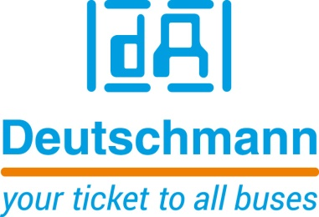

Deutschmann Automation
GmbH & Co.KG
Carl-Zeiss-Straße 8
65520 Bad Camberg
Phone: +49 6434 94330Email: info@deutschmann.de
Internet: www.deutschmann.de

PRESS RELEASE 02/2020_E

For publication approved: March 2020
Deutschmann Automation offers more functions for CANopen and CAN Layer 2 for its flexible gateway series
Bad Camberg, Germany – Deutschmann Automation, the specialist for industrial data communication, has expanded its flexible UNIGATE CX gateway series with numerous functions. The industrial DIN rail modules support almost any combination of different, common fieldbus and Industrial Ethernet interfaces to connect incompatible networks. The improved functionality applies above all to CANopen and CAN Layer 2 bus systems.
For CANopen, a mapping for communication object identifiers (COB-IDs) is available, which enables the illustration of data of one fieldbus to any other fieldbus, i.e. the individual copying of process data, is possible. All data provided by the corresponding fieldbuses can be used as output data. The mapping works in both directions, i.e. from master to slave and vice versa. For example, it can be defined that the 2nd byte of the COB-ID201 (CANopen® participant) is transferred into the fieldbus data as 7th byte. In addition to mapping for COB-IDs, the functions node guarding, EMCY messages and mapping of SDO objects are also supported.
For CAN Layer 2, configurable protocols are available, which can be used to transfer CAN data one-to-one (1:1) to a fieldbus. In addition, it is also possible to filter COB-IDs so that only these CAN data are transferred 1:1 to a fieldbus.
The UNIGATE CX gateways can be configured quickly with the WINGATE software developed by Deutschmann Automation. For complex applications, programming of a script is preferred. For this purpose, the Deutschmann Protocol Developer tool is provided free of charge.
Deutschmann Automation’s modular UNIGATE CX gateway series integrates two UNIGATE CL modules. More than 120 fieldbus and Industrial Ethernet interface variants are possible, e.g. PROFIBUS DP to PROFINET, CANopen to EtherNet/IP or Modbus TCP to PROFINET.

Deutschmann Automation offers various series of reliable fieldbus and Industrial Ethernet gateways, embedded solutions and protocol converters as key components for Industrial 4.0 applications under the brand name UNIGATE. By implementing the ready-to-use communication components, system manufacturers can save the development of suitable network interfaces and significantly reduce the development time for their products.

Deutschmann Automation

Deutschmann Automation is a German company located in Bad Camberg. For three decades, the company has designed and manufactured innovative network components for the sector of industrial data communication. Various series of Fieldbus and Industrial Ethernet gateways, and embedded solutions as well as development tools for the realization of Industry 4.0 are offered under the brand name UNIGATE. Thanks to competent quality management and the continuous further development of all products, Deutschmann Automation is one of the leading providers in the sector of automation.

Deutschmann Automation
GmbH & Co.KG
Michael Reiter
Carl-Zeiss-Straße 8
65520 Bad Camberg
Phone: +49 6434 94330
Email: info@deutschmann.de
Internet: www.deutschmann.de

Technisches Redaktionsbüro

Rosemarie Krause

Leibengerstr. 29

81829 München

Phone: +49 89 906637

