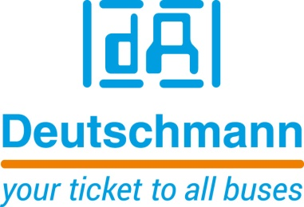

Deutschmann Automation
GmbH & Co.KG
Carl-Zeiss-Straße 8
65520 Bad Camberg
Phone: +49 6434 94330Email: info@deutschmann.de
Internet: www.deutschmann.de

PRESS RELEASE 02/2017_E

For publication approved: October 2017

Deutschmann Automation at SPS IPC Drives 2017:
Simple programming of UNIGATE modules

Bad Camberg, Germany – Deutschmann Automation, the specialist for industrial data communication, simplifies flexible protocol connection between its powerful UNIGATE modules and different terminal devices. The company will show the improved version V3 of its proven Protocol Developer in Hall 2, Booth 550 at the SPS IPC Drives exhibition in Nuremberg, Germany from November 28 to 30, 2017. The free of cost development tool is especially optimized for bus communication and is very easy to handle. The Protocol Developer is based on the self-explanatory script language developed by Deutschmann, which runs on all UNIGATE protocol converter, embedded solution and gateway products. The programming of the modules enables realisation of complex applications, which cannot be presented by a pure configuration.

In addition to modern icons for the toolbar, the Protocol Developer V3 provides simplification of the configuration, extended syntax highlighting and auto-completion of commands. Moreover, handling of variables was optimized and the user experience in the debugger was improved.

Furthermore, Deutschmann Automation offers to write the script for customers for their application. The customer then receives the source code and can carry out minor adaptations later by themselves and develop it further.

For more than two decades, Deutschmann Automation has been supplying various series of fieldbus and Industrial Ethernet gateways, embedded solutions and protocol converters as core devices for Internet of Things (IoT)-based systems under the brand name UNIGATE. With the immediately ready-to-use modules, development costs and time-to-market of an end product can be significantly optimized compared to interfaces developed by customers themselves. The innovative data communication products are manufactured by Deutschmann Automation in Germany.

Please visit Deutschmann Automation at SPS IPC Drives 2017 in Hall 2, Booth 550.

Deutschmann Automation

Deutschmann Automation is a German company located in Bad Camberg. For more than two decades, the company has designed and manufactured innovative network components for the sector of industrial data communication. Various series of Fieldbus and Industrial Ethernet gateways, and embedded solutions as well as development tools for the realization of Industry 4.0 are offered under the brand name UNIGATE. Thanks to competent quality management and the continuous further development of all products, Deutschmann Automation is one of the leading providers in the sector of automation.

Deutschmann Automation
GmbH & Co.KG
Michael Reiter
Carl-Zeiss-Straße 8
65520 Bad Camberg
Phone: +49 6434 94330
Email: info@deutschmann.de
Internet: www.deutschmann.de

Technisches Redaktionsbüro

Rosemarie Krause

Leibengerstr. 29

81829 München

Phone: +49 89 906637

