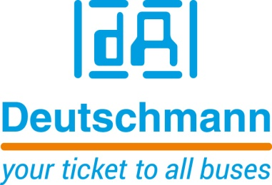

Deutschmann Automation
GmbH & Co.KG
Carl-Zeiss-Straße 8
65520 Bad Camberg
Phone: +49 6434 94330Email: info@deutschmann.de
Internet: www.deutschmann.de

PRESS RELEASE 01/2020_E

For publication approved: February 2020

embedded world 2020:
Deutschmann Automation Presents Embedded Solution for Fast
Communication via EtherCAT

Bad Camberg, Germany – Deutschmann Automation, the specialist for industrial data communication, has expanded its powerful UNIGATE IC2 series and presents the new embedded solution UNIGATE IC2 EtherCAT at embedded world 2020 in Hall 2, Booth 241. UNIGATE IC2 EtherCAT meets the strong demand from industry for a ready-to-use EtherCAT interface, which can be installed directly into a terminal device or sensor system. The integrated ARM Cortex-M4 processor ensures fast communication.

With the embedded solution UNIGATE IC2 EtherCAT, data can be processed at high speed and quickly be transferred to the customer’s application. The UART interface achieves baud rates of up to 7.5 MBaud. The SPI bus allows a transfer rate of 12 Mbit/s in master operation and 10 Mbit/s in slave operation. In addition, the all-in-one bus nodes support CANopen over EtherCAT (CoE).

The protocol connection between the UNIGATE IC2 module and the terminal device is implemented via a proprietary script, which is created in the script language developed by Deutschmann Automation in house. For programming the script, Deutschmann provides the free Protocol Developer tool. Execution time of a script line is about 10 µs. With the UNIGATE IC2 embedded series, the script execution time can be reduced by a factor of 50 to 80, compared to predecessor models from Deutschmann Automation’s proven UNIGATE IC series. Simple scripts can be executed in just a few microseconds.

Deutschmann Automation’s compatible embedded series UNIGATE IC and UNIGATE IC2 offer a wide range of different fieldbus and Industrial Ethernet communication modules, which are developed and manufactured in Germany. Furthermore, Deutschmann Automation supplies different fieldbus and Industrial Ethernet gateways and protocol converters for network-compatible systems. Implementation of the ready-to-use communication modules can significantly optimize design times and time-to-market of an end product.

Deutschmann Automation

Deutschmann Automation is a German company located in Bad Camberg. For three decades, the company has designed and manufactured innovative network components for the sector of industrial data communication. Various series of Fieldbus and Industrial Ethernet gateways, and embedded solutions as well as development tools for the realization of Industry 4.0 are offered under the brand name UNIGATE. Thanks to competent quality management and the continuous further development of all products, Deutschmann Automation is one of the leading providers in the sector of automation.

Deutschmann Automation
GmbH & Co.KG
Michael Reiter
Carl-Zeiss-Straße 8
65520 Bad Camberg
Phone: +49 6434 94330
Email: info@deutschmann.de
Internet: www.deutschmann.de

Technisches Redaktionsbüro

Rosemarie Krause

Leibengerstr. 29

81829 München

Phone: +49 89 906637

