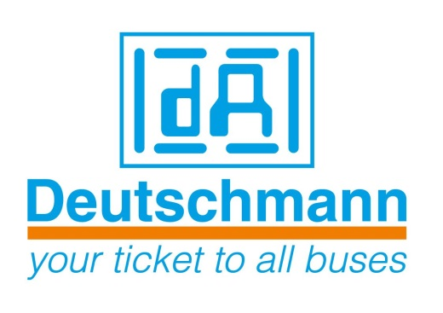

Deutschmann Automation
GmbH & Co.KG
Carl-Zeiss-Straße 8
65520 Bad Camberg
Phone: +49 6434 94330
Email: info@deutschmann.de
Internet: www.deutschmann.de

PRESS RELEASE 01/2015_E

For publication approved: October 6, 2015

Deutschmann enables quick configuration of their
Ethernet/Fieldbus gateways for Industry 4.0 applications

Bad Camberg, Germany – Deutschmann Automation, the specialist for industrial data communication, now offers a quick and easy way to configure its UNIGATE EL Ethernet/Fieldbus Gateway series with the software WINGATE developed by Deutschmann. As a result, quickly integratable, reliable network components, which come very close to a plug & play solution, are available as central devices for Industry 4.0 applications.

Standard Ethernet devices can be integrated into all modern, commonly used Fieldbus and Industrial Ethernet systems with the Gateway series UNIGATE EL from Deutschmann Automation. System manufacturers that use these gateways save themselves time-consuming development of suitable network interfaces. Adaption of the device firmware is not necessary. The slim module can be easily mounted on the DIN rail.

The series is based on the established Protocol converter UNIGATE CL. In addition to RS232, RS485 and RS422 standard interfaces, a Fast Ethernet interface is also provided. After entering the network-specific data, such as IP address, the device is immediately ready for use for communication via TCP/IP. If another transport protocol is used for communication, easy configuration follows via WINGATE. Adjustable parameters are context-sensitive displayed, dependent on the changed transport protocol.

For OEM customers, Deutschmann offers the possibility for customer-specific configuration of the products. Furthermore, the gateways can be supplied in different housing colors and with the customer’s logo, upon request. The communication modules are designed for the industrial operating temperature range.

Deutschmann Automation can be found in Hall 2, Booth 240 at the SPS IPC Drives exhibition in Nuremberg, Germany from November 24 to 26, 2015 and at the booths of Profibus & PROFINET, EtherCAT and ODVA organizations.

Deutschmann Automation

Deutschmann Automation is a German company located in Bad Camberg. For more than three decades, the company has designed and manufactured innovative network components for the sector of industrial data communication. Various series of Fieldbus and Industrial Ethernet gateways, and embedded solutions as well as development tools for the realization of Industry 4.0 are offered under the brand name UNIGATE. Thanks to competent quality management and the continuous further development of all products, Deutschmann Automation is one of the leading providers in the sector of automation.

Deutschmann Automation
GmbH & Co.KG
Michael Reiter
Carl-Zeiss-Straße 8
65520 Bad Camberg
Phone: +49 6434 94330
Email: info@deutschmann.de
Internet: www.deutschmann.de

Technisches Redaktionsbüro

Rosemarie Krause

Leibengerstr. 29

81829 München

Phone: +49 89 906637

